**PROBLEM:** Use Manning’s equation to compute the velocity of water in five rectangular open channels:



where U = velocity(m/s), S = channel slope, n= roughness coefficient, B = width(m), and H = depth(m). The data to calculate the velocity follows:

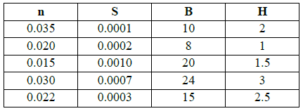

Create and a matrix for the data and compute the velocities so that output will be in a column vector where each row represents a different channel.

**SOLUTION:**

Here is my script:

%% Problem 2

% Using Manning equation compute the velocity given a 4x4 matrix of values.

% The following symbols are noted with the terms they represent

% U = velocity(m/s), S = channel slope, n = roughness coefficient, B = width(m), and H = depth(m)

% n all rows, column 1; S all rows, column 2; B all rows, column 3; H all rows column 4

clear all; close all; clc;

% Creates data matrix of all values

param = [0.035 0.0001 10 2; 0.020 0.0002 8 1; 0.015 0.0010 20 1.5; 0.030 0.0007 24 3; 0.022 0.0003 15 2.5];

% Assigns the corresponding column with its variable to streamline

n = 1; s = 2; b = 3; h = 4;

% Create row matrix of variables to allow for single line running.

y = [1,2,3,4,5];

% Single matlab line that creates a column vector of velocities.

U = (sqrt(param(y,s))./param(y,n)).*(param(y,b).*param(y,h)./(param(y,b)+2.*param(y,h))).^0.667;

fprintf('Velocities\n %f \n %f \n %f \n %f \n %f\n',U);

And it’s output:

